For Immediate Release: | Contact: | Kieran Caterina
Chief Accounting Officer
(914) 921-5149
 |  | For further information please visit
 |  | www.gabelli.com

GAMCO Investors, Inc. Reports Results for the First Quarter 2026

- Quarter End AUM of $35.1 Billion (+12.5% versus Q1 2025)
- Quarterly Revenues Grew 14.9% to $65.9 Million
- First Quarter EPS of $0.66 versus $0.81 in the First Quarter of 2025
- Strong Liquidity Position and Cash Generation Support Capital Returns: $200.9 Million in Cash and Investments with No Debt; 21.6 Million Shares Outstanding After Repurchasing 449,535 Shares During Q1 2026
Palm Beach, Florida, May 5, 2026 – GAMCO Investors, Inc. (“Gabelli”) (OTCQX: GAMI) today reported its operating results for the quarter ended March 31, 2026.

Financial Highlights

Giving Back to Society - $82 million since IPO

Since our initial public offering in February 1999, our firm’s combined charitable donations total approximately $82 million, including $48 million through the shareholder designated charitable contribution program. Based on the program created by Warren Buffett at Berkshire Hathaway, our corporate charitable giving is unique in that the recipients of Gabelli’s charitable contributions were chosen directly by our shareholders, rather than by our corporate officers. Since its inception in 2013, Gabelli shareholders have designated charitable gifts to approximately 350 charitable organizations.

The charitable giving program continues today with the Gabelli Funds Foundation, a private foundation, established in September 2024.

About Gabelli

Gabelli (OTCQX: GAMI), established in 1977, is a widely-recognized provider of investment advisory services to 27 open-end funds, 13 United States closed-end funds and one United Kingdom investment company, 8 actively managed exchange traded funds, one société d’investissement à capital variable, and approximately 1,900 institutional and private wealth management investors principally in the U.S. The Company’s revenues are based primarily on the levels of assets under management and fees associated with the various investment products.

In 1977, Gabelli launched its well-known All Cap Value equity strategy, Gabelli Value, in a separate account format and in 1986 entered the mutual fund business. Today, Gabelli offers a diverse set of client solutions across asset classes (e.g. Equities, Debt Instruments, Convertibles, non-market correlated Merger Arbitrage), regions, market capitalizations, sectors (e.g. Gold, Utilities) and investment styles (e.g. Value, Growth). Gabelli serves a broad client base, including institutions, intermediaries, offshore investors, private wealth, and direct retail investors.

Revenue

The year over year increase in Funds revenues was primarily the result of higher average assets under management. The Institutional and Private Wealth Management increase in revenues was the result of higher equity assets at the beginning of the quarter, which are generally used to calculate the revenues. The increase in distribution fees and other income was attributable to greater equity mutual fund assets paying distribution fees.
Expenses

The $5.5 million higher compensation expense in the first quarter of 2026 compared to the prior year quarter is comprised of $2.8 million of waived compensation in the 2025 quarter, $1.6 million of higher fixed compensation, and $1.1 million of higher variable compensation.

Operating Margin

The operating margin, which represents the ratio of operating income to revenue, was 31.0% for the first quarter of 2026 compared with 32.4% for the first quarter of 2025.

Non-Operating Income/ (Loss)

Non-operating loss was $0.8 million in the first quarter of 2026 compared to non-operating income of $1.2 million in the first quarter of 2025.

Other Financial Highlights

The effective income tax rate for the first quarter of 2026 differed from the statutory Federal tax rate of 21% primarily due to state income taxes. The ETR for the first quarter of 2026 consisted of the statutory Federal tax rate of 21% and a net state income rate of 5.7%. The ETR for the first quarter of 2025 consisted of the statutory Federal tax rate of 21% offset by a net state income credit rate of 13.2%, relating to the release of an uncertain tax position accrual as a result of a settlement with New York State for the audit years 2007-2014.

At March 31, 2026, cash, cash equivalents, seed capital, and investments were $200.9 million with no debt. There were 21.6 million shares outstanding as of March 31, 2026.

Assets Under Management

Assets under management on March 31, 2026 were $35.1 billion, an increase of 0.6% from the $34.9 billion on December 31, 2025. The quarter’s increase consisted of net market appreciation of $0.7 billion partially offset by net outflows of $0.4 billion and distributions, net of reinvestments, of $0.1 billion.

Mutual Funds

Assets under management in Open-end Mutual Funds on March 31, 2026 were $9.4 billion, unchanged from December 31, 2025. The quarterly activity included:

- Net market appreciation of $156 million;
- Net outflows of $172 million; and
- Distributions, net of reinvestment, of $5 million.
ETFs

Assets under management in ETFs on March 31, 2026 were $149 million, an increase of 40.6% from the $106 million at December 31, 2025. The quarterly change was attributed to:

- Net inflows of $50 million; and
- Net market depreciation of $7 million;

In February 2026, the SEC approved a filing to add an ETF share class, or “Class E,” to existing open-end mutual funds.

Closed-end Funds

Assets under management in Closed-end Funds on March 31, 2026 were $8.2 billion, unchanged from December 31, 2025. The quarterly activity included:

- Net market appreciation of $159 million;
- New offerings of $3 million of 5.2% preferred shares;
- Distributions, net of reinvestment, of $145 million; and
- Net outflows of $33 million from the repurchase of $34 million of common stock and the redemption of $20 million of preferred shares partially offset by the issuance of $20 million common stock.

Institutional & PWM

Assets under management in Institutional & PWM on March 31, 2026 were $11.6 billion, a decrease of 1.8% from the $11.8 billion on December 31, 2025. The quarterly change was due to:

- Net outflows of $590 million; and
- Net market appreciation of $378 million.

SICAV

Assets under management were $10 million in the GAMCO All Cap Value sleeve and the GAMCO Convertible Securities sleeve on March 31, 2026, unchanged from December 31, 2025.

100% U.S. Treasury Money Market Fund – Ranked #1 Government Retail Fund as of March 31, 2026

Assets under management in our 100% U.S. Treasury Money Market Fund (GABXX) on March 31, 2026 were $5.8 billion, an increase of 7.8% from the $5.4 billion on December 31, 2025.
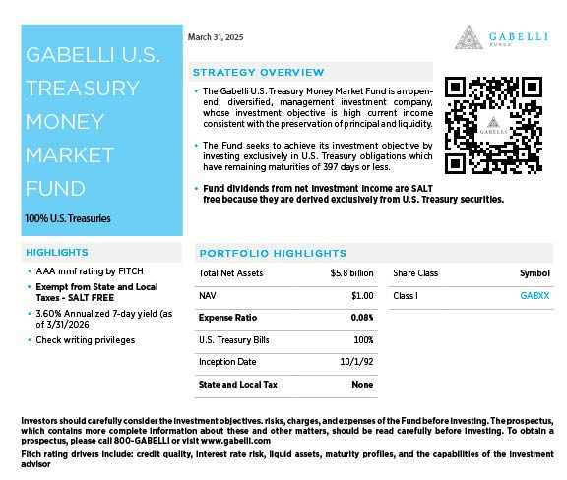

Assets Under Administration

AUA on March 31, 2026 were $0.8 billion, unchanged from December 31, 2025.

Return to Shareholders

During the first quarter of 2026, Gabelli repurchased 449,535 shares for $11.2 million at an average investment of $24.96 per share and paid a regular quarterly dividend of $0.10 per share totaling $2.2 million, returning $13.4 million to shareholders. At March 31, 2026, the total shares remaining under the Stock Repurchase Program were 649,545. From April 1, 2026 to May 5, 2026, the Company has repurchased 30,962 shares at an average price of $23.47 per share for an aggregate purchase price of approximately $0.7 million.

On May 5, 2026, Gabelli’s board of directors declared a regular quarterly dividend of $0.10 per share, payable on June 30, 2026 to class A and class B shareholders of record on June 16, 2026.

Balance Sheet Information

As of March 31, 2026, cash, cash equivalents, seed capital, and investments totaled $200.9 million, compared with $195.5 million as of December 31, 2025. As of March 31, 2026, stockholders’ equity was $172.2 million compared to $171.5 million as of December 31, 2025. The increase in stockholders’ equity resulted from $14.4 million in net income offset partially by $11.2 million of stock buybacks and $2.2 million in dividends.

Symposiums/Conferences

- On February 26th, we hosted our 36th Annual Pump, Valve & Water Systems Symposium. The symposium focused on themes crucial to this industry, including infrastructure spending, resource security, conservation, and M&A.

- On March 19th, we hosted our 17th Annual Specialty Chemicals Symposium. The symposium featured presentations from senior management of leading specialty chemicals companies, with a focus on pricing power, margin recovery, interest rates, destocking, global supply chain, global demand trends, and the M&A environment.

- On April 9th, we hosted our 12th Annual Waste & Environmental Services Symposium. The conference featured presentations by senior management of several leading companies, with a focus on the themes of waste, water treatment, and the environment.

- On May 1st, we hosted our 17th annual Omaha Research Trip in conjunction with the Berkshire Hathaway Annual Meeting. This Value Investor Conference attracted a record number of participants with Gabelli portfolio managers anchoring panels with noted Berkshire experts and regional CEOs.

Our 2026 symposiums and conferences:

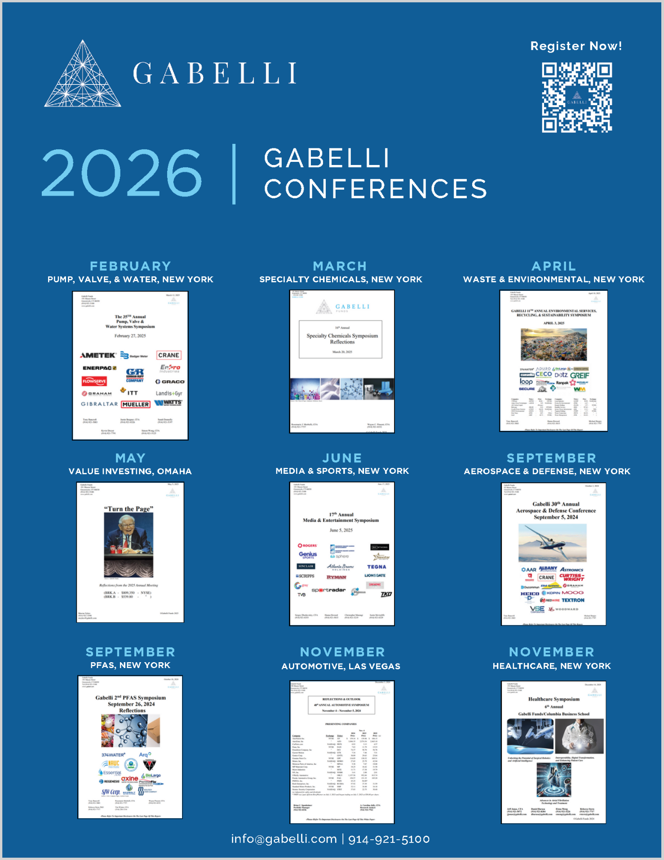
Firm Update

On March 22nd, the Board executed and Management implemented the firm’s succession plan that has been in place for several years. In accordance with that plan, Christopher J. Marangi was named President of the Company on March 22nd.
While the timeline for Mario Gabelli’s return remains undetermined, the day-to-day operations of the Company will continue to be led by co-CEO, Douglas R. Jamieson, and Christopher J. Marangi and the value portfolios continue to be managed by the team.
The Board is pleased that the plan put in place years ago has been successfully implemented.

CAUTIONARY STATEMENT REGARDING FORWARD-LOOKING STATEMENTS
Our disclosure and analysis in this press release, which do not present historical information, contain “forward-looking statements” within the meaning of the U.S. Private Securities Litigation Reform Act of 1995. Forward-looking statements convey our current expectations or forecasts of future events. You can identify these statements because they do not relate strictly to historical or current facts. They use words such as “anticipate,” “estimate,” “expect,” “project,” “intend,” “plan,” “believe,” and other words and terms of similar meaning. They also appear in any discussion of future operating or financial performance. In particular, these include statements relating to future actions, future performance of our products, expenses, the outcome of any legal proceedings, and financial results. Although we believe that we are basing our expectations and beliefs on reasonable assumptions within the bounds of what we currently know about our business and operations, the economy, and other conditions, there can be no assurance that our actual results will not differ materially from what we expect or believe. Therefore, you should proceed with caution in relying on any of these forward-looking statements. They are neither statements of historical fact nor guarantees or assurances of future performance.

Forward-looking statements involve a number of known and unknown risks, uncertainties and other important factors, some of which are listed below, that are difficult to predict and could cause actual results and outcomes to differ materially from any future results or outcomes expressed or implied by such forward-looking statements. Some of the factors that may cause our actual results to differ from our expectations include risks associated with the duration and scope of the ongoing coronavirus pandemic resulting in volatile market conditions, a decline in the securities markets that adversely affect our assets under management, negative performance of our products, the failure to perform as required under our investment management agreements, and a general downturn in the economy that negatively impacts our operations. We also direct your attention to the more specific discussions of these and other risks, uncertainties and other important factors contained in our Annual Report and other public filings. Other factors that could cause our actual results to differ may emerge from time to time, and it is not possible for us to predict all of them. We do not undertake to update publicly any forward-looking statements if we subsequently learn that we are unlikely to achieve our expectations whether as a result of new information, future developments or otherwise, except as may be required by law.

Gabelli Funds, LLC is a registered investment adviser with the Securities and Exchange Commission and is a wholly owned subsidiary of GAMCO Investors, Inc. (OTCQX: GAMI).
Investors should carefully consider the investment objectives, risks, charges and expenses of the fund before investing. The prospectus, which contains more complete information about this and other matters, should be read carefully before investing. To obtain a prospectus, please call 800 GABELLI or visit www.gabelli.com
Fitch rating drivers include: credit quality, interest rate risk, liquid assets, maturity profiles, and the capabilities of the investment advisor

Money Market Fund
Investment in the fund is neither guaranteed nor insured by the Federal Deposit Insurance Corporation or any government agency. Although the fund seeks to preserve the value of your investment at $1.00 per share, it cannot guarantee it will do so. The fund’s sponsor has no legal obligation to provide financial support to the fund, and you should not expect that the sponsor will provide financial support to the fund at any time. You could lose money by investing in the fund.

Returns represent past performance and do not guarantee future results. Investment returns and the principal value of an investment will fluctuate. When shares are redeemed, they may be worth more or less than their original cost. Current performance may be lower or higher than the performance data presented. Visit www.gabelli.com for performance information as of the most recent month end.

